This Acknowledges That

Has Successfully Completed

2021 CAQH Rule Changes: Stop Reimbursement Delays
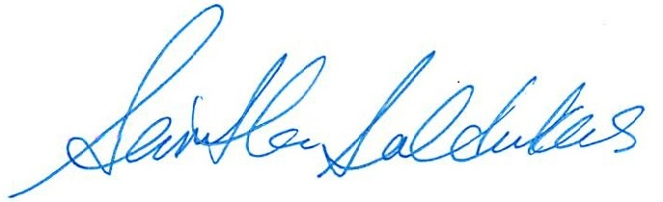

Signed, Samantha Saldukas, President

